Bake something yummy! Talk about the recipe and what you’re doing, the measurements and where the ingredients come from.    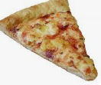  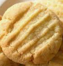 | - * Look out for numbers in the environment. What numbers can you see and where? Record the numbers and where they are.  - * Count different objects.  - *. Find the same amount of different items to help your child understand what numbers mean. For example, find 3 spoons, 3 hats or 3 socks. Change the number and do it again! |     Draw a picture of yourself doing something you enjoy. Can you label the picture by writing your name?  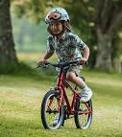
Go for a walk and look for signs of Autumn. Can you see any conkers? What colour are the leaves? Draw and write about the things you see. Create a leaf collage picture.  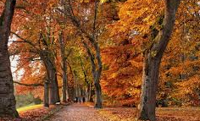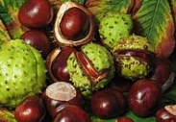 | Sing lots of nursery rhymes. Can you draw a picture of your favourite rhyme?  You could visit the BBC website below to help you.  https://www.bbc.co.uk/teach/school-radio/nursery-rhymes-a-to-z-index/z4ddgwx    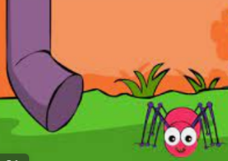 | Get active! Exercise is good for you and it’s lots of fun! You could dance to music, go for a walk or count how many times you can hop or jump. There are lots of children’s exercise videos online, too.  Joe Wicks has made videos with Hey Duggee and you can find them on YouTube.  https://www.youtube.com/playlist?list=PLyCLoPd4VxBvIsxs4yYGusHvaTq9vhN0H  