Talk about Bonfire Night and keeping safe. Can you create a bonfire picture?  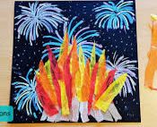 | - * Can you sort your socks? Match up different socks looking at the colours and patterns and see if you can make a pair?  - *Play hide and seek with your favourite teddy. Can you use positional words to describe where they are? On the table, under the chair, next to the T.V.  - * Can you write your numbers from 1- 5 correctly. Can you make the numbers using different items inside and outside?  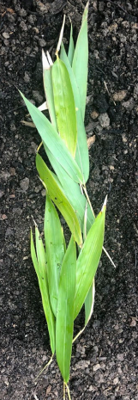 | Who lives in your family? Make a family tree. The older family members go at the top of the tree and the younger ones at the bottom.  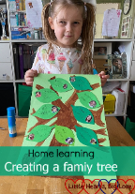
Phonics scavenger hunt. Find things around your house for the following sounds: s, a ,t, p, i, n, m, d, g, o, c, k.  Draw the items and write the initial sound correctly.  S | Write a shopping list to make some Christmas cookies. Whilst making them enjoy listening to some Christmas songs. When cooked, enjoy eating them watching your favourite Christmas film.   | Teach your family the ‘Days of the Week’ song. Keep a weather chart for a week. Draw a picture to show what the weather is like each day and discuss what clothing is best for the day.  