Go on a walk, what do you see?  Can you draw a map of your route? Add labels. Can you tell your friend where you went and what you saw?  Could you use directions and tell them how to get there? Can you write some directions for them?  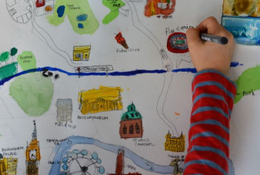 | - * Can you recognise all your numbers to 20 and form them correctly?  * Count out 20 items and look at sharing them between two in different ways.  *What shapes can you see in the environment?  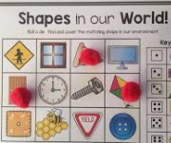 | Can you write all your letters correctly?  Can you write your full name with all your letters formed correctly? Including your surname?  Play eye spy and other games with your friends and family.  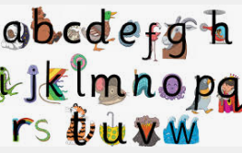
Look at different maps. Can you find where you live. If you could go anywhere in the world, where would you go and why? A jungle, desert or the Artic?  Draw, paint, write or make what you think you would see there.  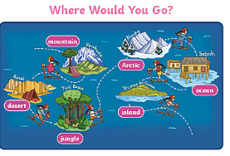 | Collect lots of boxes and things you usually throw away. What type of transport can you make with them? Be imaginative and see what you can make. Can you make a rocket that might blast into space or a boat that sails to America?  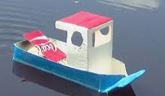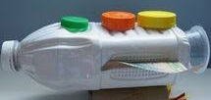 | Go to Queen’s Park and have fun outside riding your bike or your scooter around the cycle track. Can you ride a bike?  77

