Talk about Chinese New Year and customs around the celebration. Make a page with information about Chinese New Year or make a Chinese lantern.  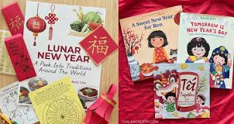 | - * Go on a shape hunt. What can you see that is a circle, square, rectangle or triangle?  - *Make repeating patterns using different items, socks or other items around the house  - * Can you write your numbers from 1- 10 correctly. Can you make the numbers using different items inside and outside?  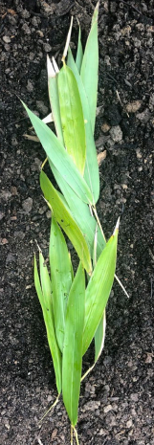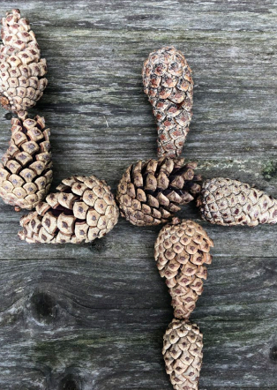 | Have you ever been to London? Look at London on the map. What different landmarks can you see? Where is Buckingham Palace? Who lives there?  Who is our King? Can you draw a map of London and add different landmarks to it? Draw or add pictures or photos. What river runs through London?  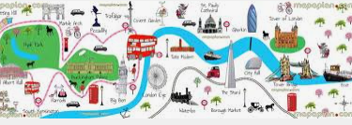
Use your phonics to write labels around the house, for example bed, tap, sock, sink, hat, pan, jam, cup, pot can. What material are they made from?   | Read or listen to some traditional tales. Can you make a puppet that you can use to retell the story? You could use a paper bag or a wooden spoon.  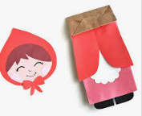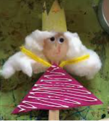 | Go outside and look for sign of Winter. What do the trees look like? What is the weather like? What clothes do you need to wear? Can you make a Winter tree?  