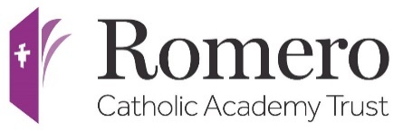

Consultation Response Form
School: St Marys RC Primary School Burnley

All Admission Authorities must consult on their admission arrangements that will apply to admission applications for the following school year. At least every 7 years, Admission Authorities must consult on their admission arrangements, even if there have been no changes during that period.
We would welcome your views on the admission arrangements for St Marys RC Primary School Burnley for the academic year 2025-2026.
The consultation period will run from 8 December 2023
You can respond in any of the following ways:
- By completing this consultation response form and returning it to Office 204, Group First House, Shuttleworth Mead, Padiham, BB12 7NG.
- By emailing your response directly to contact@romerocat.com

1. Have you read and understood the full policy
☐ Yes
☐ No
2. Do you need any sections clarifying in more detail?
☐ Yes
☐ No
- Please can you state which section(s) of the policy you need greater clarification on…

4. Please state if there is anything further which you feel needs adding or removing.

Thank you for your response.

